**HOME SECURITY**

**Group Members:**

**Kishan Polekar**

**Manthan Kale**

**Monis Ahmed Khan**

**CS3910 Software Engineering**

**Instructor: Sunae Shin**

**Submitted on: Oct 10, 2018**

**Fall 2018**

**TABLE OF CONTENTS**

Introduction………..……………………………………………………………………………………1

Product Description……………………………………………………………………………………1

Sequence Diagram 1…………………………………………………………………………………..4

Architecture……………………………………………………………………………………………..4

Class Diagram…………………………………………………………………………4

Pseudocodes…………………………………………………………………….……5

Sequence Diagram 2…………………………………………………………………………………..6

Algorithm and Data structure………………………………………………………………………………………..……….7

Software tools ………………………………………………………………………………………….7

Risks…………………..…………………………………………………………………………………7

Logs of Meetings……………………………………………………………………………………….8

Contribution Report…………………………………………………………………………………….9

References………………………………………………………………………………………………9

**Introduction**

The main software components in the home security system are database, biometrics, and the mobile application. The first thing that anyone interacts with is the cameras and biometric system. It will access the database, read information stored there, and determine if access is to be granted. We will design the system such that the database has multiple copies, both online and offline just in case internet connection goes off and also the wires do not work. When internet is back on, the data is synced to the cloud storage. We will be using distributed systems, and hence loss of data will not be an issue. The biometrics module will take inputs like fingerprints or Face ID and verify it with the data stored either in its volatile memory or with the database. The mobile application will make use of both biometrics as well as database. Hence, the database is the soul of the system.

There will be many main and sub-classes in the system. It will store values in a csv file or an excel sheet. These will contain many columns, with proper default values. The database schema will look something like this:

Owner (id, fname, lname, age, finger, face, voice, priv)

There will be several columns added/deleted from each database as the requirements come in. We will make sure to keep the program as flexible as possible in terms of needs.

**Product Description**

A total part of home security. A way to lessen human exertion and stresses. A home security framework is introduced in each home to anticipate against theft and introduce a new level of safety. There are numerous homes that have crude frameworks introduced and a couple of the advanced homes are being furnished with top of the line advances. A few homes still utilize basic bolts and keys. Security is foremost in houses today, and to accomplish this, numerous most recent innovations like facial recognition, unique finger print scanner, PIN codes, and so forth have been developed.

The main motive of this project is to eliminate the slightest error in home security that might occur due to software or hardware present in today’s systems. We can achieve this by improving existing software, implementing new ideas, and installing new devices with advanced code that will enable the owner to feel safe in his/her adobe.

Nowadays, homes have to be self-sustainable in terms of security. The main things that are involved in security planning for any new home include analyzing the cost of installation of new hardware and software, predicting the time taken to install the system, analyzing the customer’s needs and deciding the level of security needed, surveying existing systems, and finally installing a complete product that satisfies the customer’s needs.

The core handling of this product will be through the client’s phone after installing all the hardware, database and software’s around the house. An application will be installed in the client’s phone through which the owner will have to provide its credentials and then can control everything.

For the application we will be using XCode to design and format the user interface. It’s easy to understand and implement. Making further adjustments and maintenance goes handy with it too. The database where the passwords, the analysis, default components and hardware properties will be saved is going to be designed with Hadoop framework with SQL. The front end will be designed on swift. The back end will be all written in python. The hardware includes cameras (thermal and night), internet-controlled lock system in doors and windows, main door display, wiring for connecting all equipment in case internet fails and a stable high-speed internet with modem

The features of the planned system. The first and foremost objective of this project will be to define the specific roles of each user in the house. There can be a maximum of two owners who will have an “all-access pass” for the home security. They will be able to decide when to allow someone in or when to deny a person, who to add as a guest/visitor, etc. They will be able to change the central PIN of the security system, and also make changes in any fingerprints. The new system that will be installed will have at least the following features:

* Biometric scanner; including but not limited to facial recognition, fingerprint scanner.
* Central PIN which can be used to open all entrances of the house.
* Heat sensor cameras with thermal and night vision.
* Live Tracking: Centralized monitoring system that will record activities in the house on a regular basis and upload that data into a database.

The system is designed such that there will be a main entrance in the house which will have a board. The board will be equipped with a camera, which will scan a face. All the cameras in the house will be equipped with thermal and night vision for enhanced security. The board will also have a PIN entering system and a fingerprint scanner. This can be used in the case face detection fails or there is a guest user in the house. The owner will be notified and asked if that person is to be allowed in the house.

We as humans can make mistakes all the time. Can we make something that can think of security by itself? Be smart enough and reduce human effort. That’s what technology is for right?

Considering traditional homes in mind, we don’t have many security measures in our houses. Just basic doors with a key lock, door chain and one additional lock to secure the door. That’s it. What can go wrong?

Locks can wear out, keys can get lost, copies can be made, windows can be left open, anyways windows aren't too secure. Nowadays in advanced homes in urban areas, we see a lot of technological advancements related to security and safety. Biometric access, heat sensors, advanced fire alarm system but still there can be glitches.

So, what can we do to make sure we create something that is smart enough to handle all the problems stated above?

There will be three levels of users: owner, visitor, and servants. The owner will have access to all rooms regardless, the visitors cannot access certain rooms, and the servants will also have limited access to the house. All this will be specified by the owner. If any new body is detected at the entrance, the owner will have a link to add that person as a “trusted” individual. This person’s roles and accesses will be defined by the owner, saved to the database on the cloud, and remembered the next time this person tries to enter the house. If the owner decides not to add the person or fails to add him/her within the next 24 hours, the link will expire, and the owner will be asked again the next time.

There will be three things going on in the house at all times: a facial recognition software running to detect any new faces, a thermal sensing technology that will look for any human, and a live tracking facility that will keep uploading feeds to the server online. These feeds will

contain the daily activity, movement patterns of people in the house, new faces that were not saved, etc. If anything, unusual is detected, the owner will be notified immediately.

There will also be a vacation mode in the security system. This can be enabled by the owner whenever they are going out for more than a couple of days. This will lock down the house after checking everyone has left. In vacation mode, if anyone tries to enter the house, the owner will be notified and asked if the person is to be allowed. Suppose a pest control service was requested, the house will open only those rooms which the owner specifies, keep them open, and lock down the house once again. In case there is a break in during non-vacation time, the owner will be notified immediately, an alarm will sound, and the nearest police station will also be called. The house will not be locked down, but the unusual person’s biometrics will be stored. This will be done to prevent the burglar from being locked down in the house and causing harm to the residents. In case of a break in during vacation time, the house will lock down along with all the above being executed. In case of fire, the nearest fire department will also be notified in addition to the sprinklers being activated.

Finally, the system is self-sustainable. Meaning, it will update itself in pieces (not all parts of the system at the same time to ensure a monitoring is active at all times), will notify the owner about any faults either in hardware or software, and ask the user to update the system time to time and also in case of any failures.

The tools and resources can be expensive for these kinds of projects but it’s better to be safe than sorry. The tools that we can use to make it happens includes cameras with thermal detection and night vision, software controlled physical locks, 24-hour cellular, and internet facility. And finally, a database to keep track of everything. A live feed will be up all the time and it will store information on this database. Discussing the target customer for personnel use, this product is not for everyone. It is an advanced level security system. Not everyone can afford a product like this. And even if they can most people feel secure enough with the traditional system. But the system does not only solve the security purposes it’s a safety system too. Fire alarms, handling emergency situation and could save someone’s life.

The product can also be modified for industrial use, banks, offices, museums or anywhere where the customer needs additional security and safety.

|  |  |
| --- | --- |
| ADVANTAGES | DISADVANTAGES |
| Quick response time | Very expensive |
| Adaptive | Software or hardware errors could occur |
| Learns from itself | Not portable. |
| Stores data for future use, analyze situations and act according |  |
| Secure |  |
| Provides all aspects of security |  |

**Sequence diagram for the Fire detection on vacation mode**

This is the sequence diagram that shows that what will happen if the fire is detected when the owner is not at home and gone for the vacation.

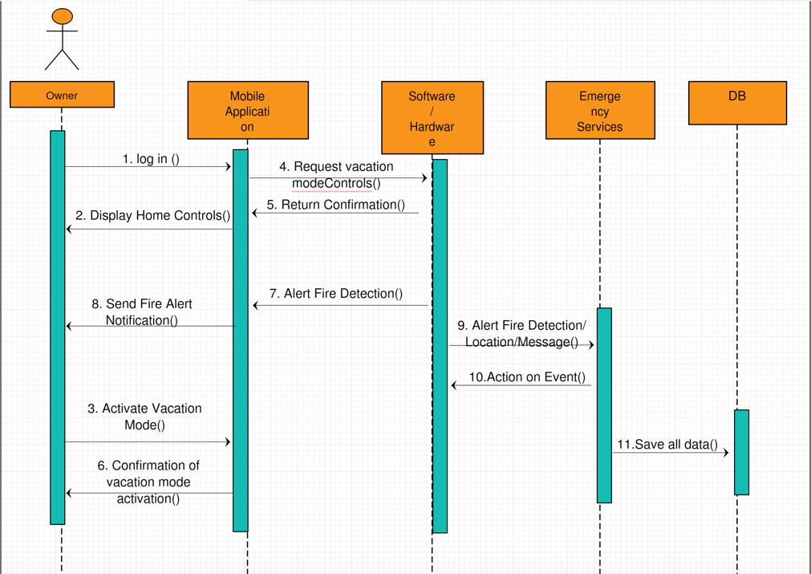

*Sequence diagram for fire detection on vacation mode*

**Architecture**

The two main classes will be owner and database. The pseudocodes and class diagram will look something like this:

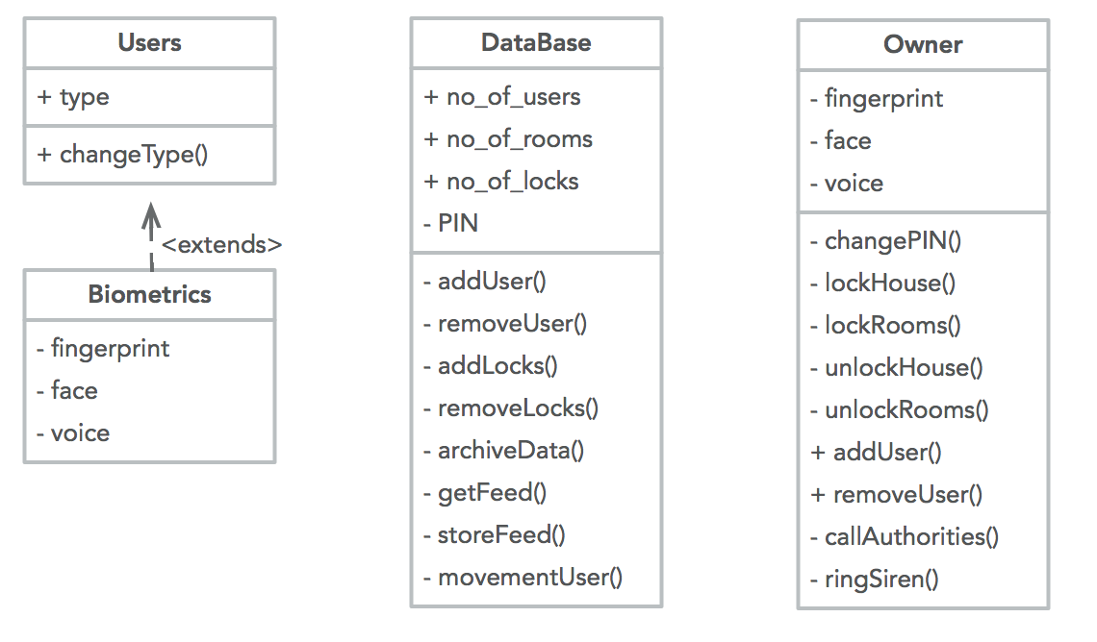

*Class diagram for Home Security*

***Pseudocode for Owner:***

class Owner():

private fingerprint

private face

private voice

def __changePIN(pin):

#changes the central PIN for the house

def __lockHouse():

#locks down the house

def __lockRooms():

#locks down particular room(s)

def __unlockHouse():

#unlocks the house

def __unlockHouse():

#unlocks particular room(s)

def addUser():

#adds a new user

def removeUser():

#removes an existing user

def __callAuth():

#calls the police/fire/ambulance

def __ringSiren():

#rings the central siren to alert everyone

***Pseudocode for Owner:***

class Database():

private PIN

def __addUser():

#adds a new user

def __removeUser():

#removes an existing user

def __addLocks():

#adds additional locks for the house

def __removeLocks():

#removes existing locks if they are not in use or do not need security

def __archiveData():

#moves the data from temporary to permanent storage in the database

def __getFeed():

#retrieves the feed for user/authorities to view

def __storeFeed():

#refreshes the feed and stores any unsaved data from LIVE feed to the database

def __movementUser():

#tracks the movement of the user and saves/remembers it

**Layered Architecture**

**Sequence diagram to add user**

This is the diagram that shows how the additional users like guests or the workers will be added in the system so that their permission of entering the house can be granted.

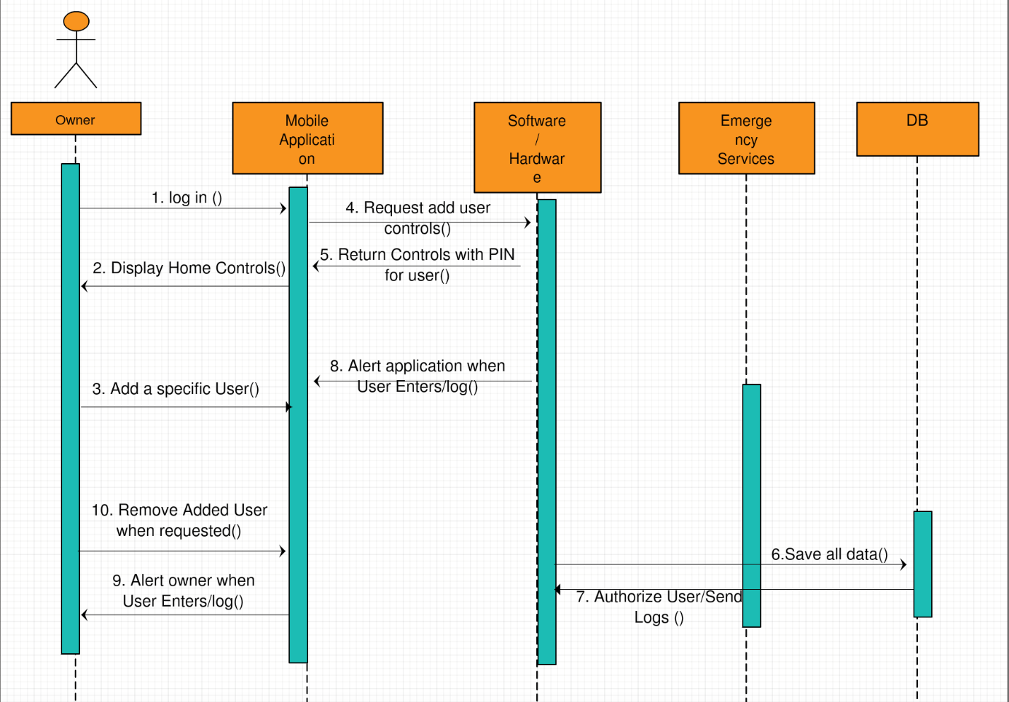

*Sequence Diagram for adding a new user*

**Data Structure and Algorithm**

For this home security model, we are going to use various data structures like Arrays, linked list and also hash tables in order to store and retrieve data from the database. The algorithm that we are going to use is Breadth First Search (BFS). BFS will be used to search various information in the database like who came last month in the house or what are the items that are kept in the house and how they are arranged. We are also going to use linear probing to search the hash table that will be used to store different information.

**Software tools**

There are many programming languages that can be used. For this model we need two types of software; one that will work in the front hand and the other that will control the database. The programming language that will be used for this home security model are HTML, CSS, JavaScript, XMl, AngularJS. These are the languages that will work in the front end. For the back-hand PHP, MySQl. Will be used to control the database that will be used to store the various information. For other controlling software we are going to use different object-oriented programming language such as JAVA and Python. To work on these programming languages, we will need different compilers that will run the codes of the Software.

**Risks:**

The problem that can occur while making this project are:

1. There can be various software issues the software that will be made might not work properly or as per the requirement of the system. It can be fixed by looking for the bugs and the error that will occur with time. All the errors will be removed as we find them.
2. There could be problem in stalling different equipment’s such as cameras and different biometric tools. To make sure that this is done correctly we need properly look at all the installation techniques and everything to make sure that it is installed properly.
3. This security system is very important, and everything should be done perfectly. The employees that will work to install the system can work carelessly that can make a big error. In order to avoid this problem, we need to keep an eye on all the workers and their work.

**Logs of Meetings**

|  |
| --- |
| **Software engineering Project report** |

|  |  |  |
| --- | --- | --- |
| Date : 10/28/18 | Time : 5:00 pm | Location: Library |

|  |  |
| --- | --- |
| Meeting called by | Kishan Polekar |
| Type of meeting | General |
| Facilitator | Monis Ahmed Khan |
| Note taker | Manthan Kale |
| Timekeeper | Monis Ahmed Khan |
| Attendees | All the members |

|  |
| --- |
| Agenda Topic 1: What is the design and the architectural design of the model? |

|  |  |
| --- | --- |
| Time: 6:00 pm | By: Kishan Polekar |
| Discussion | About the architectural design of the home security model |
| Conclusions | Made the design |

|  |  |  |
| --- | --- | --- |
| Action Items | Person Responsible | Deadline |
| Present all the ideas for the Design | Monis Ahmed Khan | Time 6:30pm |
| Take the notes, check and implement it. | Manthan Kale | Time 6:30pm |

|  |
| --- |
| Agenda Topic 2: How to make the report |

|  |  |
| --- | --- |
| Time 7:00 pm | By: Monis Ahmed Khan |
| Discussion | What are the Algorithm and data structure that is used in the model? |
| Conclusions | Figured out the algorithm that will be used in the model |

|  |  |  |
| --- | --- | --- |
| Action Items | Person Responsible | Deadline |
| Set of algorithm and their uses | Manthan Kale | 8:00 pm |
| Check to see which ones are the best to use | Kishan Polekar | 8:00 pm |

|  |
| --- |
| Agenda topic 3: The final report and revision |

|  |  |
| --- | --- |
| Time 9:00 pm | By: Manthan Kale |
| Discussion | What are the software tools that needs to be used? |
| Conclusions | Used the best software tools and got the tools. |

|  |  |  |
| --- | --- | --- |
| Action Items | Person Responsible | Deadline |
| Take all the work and organize it. | Monis Ahmed Khan | 10:00 pm |
| Verify the report check for any errors | Kishan Polekar | 11:00 pm |

**Contribution Report**

Team Name: Peaky Blinders

Team Leader: Kishan Polekar

Members: Monis Ahmed Khan, Manthan Kale

|  |  |  |  |
| --- | --- | --- | --- |
|  | Kishan Polekar | Manthan Kale | Monis Ahmed Khan |
| Architectural design | Yes | Yes | No |
| Design | No | Yes | Yes |
| Algorithm | Yes | No | No |
| Software tools | No | No | Yes |
| Final check | Yes | Yes | Yes |

|  |  |  |  |  |
| --- | --- | --- | --- | --- |
|  | Kishan Polekar | Monis Ahmed Khan | Manthan Kale | Total |
| Contribution | 33.34% | 33.33% | 33.33% | 100% |

**References:**

https://www.researchgate.net/profile/Mohammed_Mynu ddin/publication/293173717_Design_and_Implementatio n_of_Smart_Home_Security_System/links/56b610a608ae 5ad360598bfb/Design-and-Implementation-of-Smart- Home-Security-System.pdf?origin=publication_detail

<https://www.google.com/imgres?imgurl=https://scrumorg-website-prod.s3.amazonaws.com/drupal/inline-images/2017-03/SprintBacklog_0.png&imgrefurl=https://www.scrum.org/resources/what-is-a-sprint-backlog&h=404&w=665&tbnid=OUH06oIVRZgLJM:&q=sprint+backlog&tbnh=128&tbnw=210&usg=AI4_-kTN7Gvwki8Otwzg9hXJkfG7e2sGcg&vet=12ahUKEwi12M_bu_rdAhUKPq0KHf12ABUQ9QEwAHoECAsQBg..i&docid=nh6Atx9SOgg68M&client=safari&sa=X&ved=2ahUKEwi12M_bu_rdAhUKPq0KHf12ABUQ9QEwAHoECAsQBg#h=404&imgdii=XQ4AmgKhC8tV_M:&tbnh=128&tbnw=210&vet=12ahUKEwi12M_bu_rdAhUKPq0KHf12ABUQ9QEwAHoECAsQBg..i&w=665>

<https://www.google.com/imgres?imgurl=https://www.scrum-institute.org/images_scrum/Example_Scrum_Product_Backlog.jpg&imgrefurl=https://www.scrum-institute.org/The_Scrum_Product_Backlog.php&h=285&w=434&tbnid=ibqP_Oqbl_N6LM:&q=product+backlog&tbnh=138&tbnw=210&usg=AI4_-kRKxVjlvKuKaeV4ZNdxeswNAH-VSQ&vet=12ahUKEwjq1M7Su_rdAhVST6wKHYlbCUoQ9QEwAHoECAUQBg..i&docid=l6iUQNkPepqhfM&client=safari&sa=X&ved=2ahUKEwjq1M7Su_rdAhVST6wKHYlbCUoQ9QEwAHoECAUQBg>